BUSINESS INTELLIGENCE AND TOOLS
EXPERIMENT - 3

Aim: To design and implement a dimensional data model using Microsoft Power BI by transforming transactional data from the Global Superstore dataset into a Star Schema.

Step-wise Solution
PART A – LOAD DATASET
Step 1: Open Power BI Desktop
Open Microsoft Power BI Desktop.
Step 2: Import the Dataset
Go to Home → Get Data → Excel Workbook and select Global Superstore Dataset.xlsx.
Step 3: Select Worksheets
Select Orders, Returns, and People worksheets.
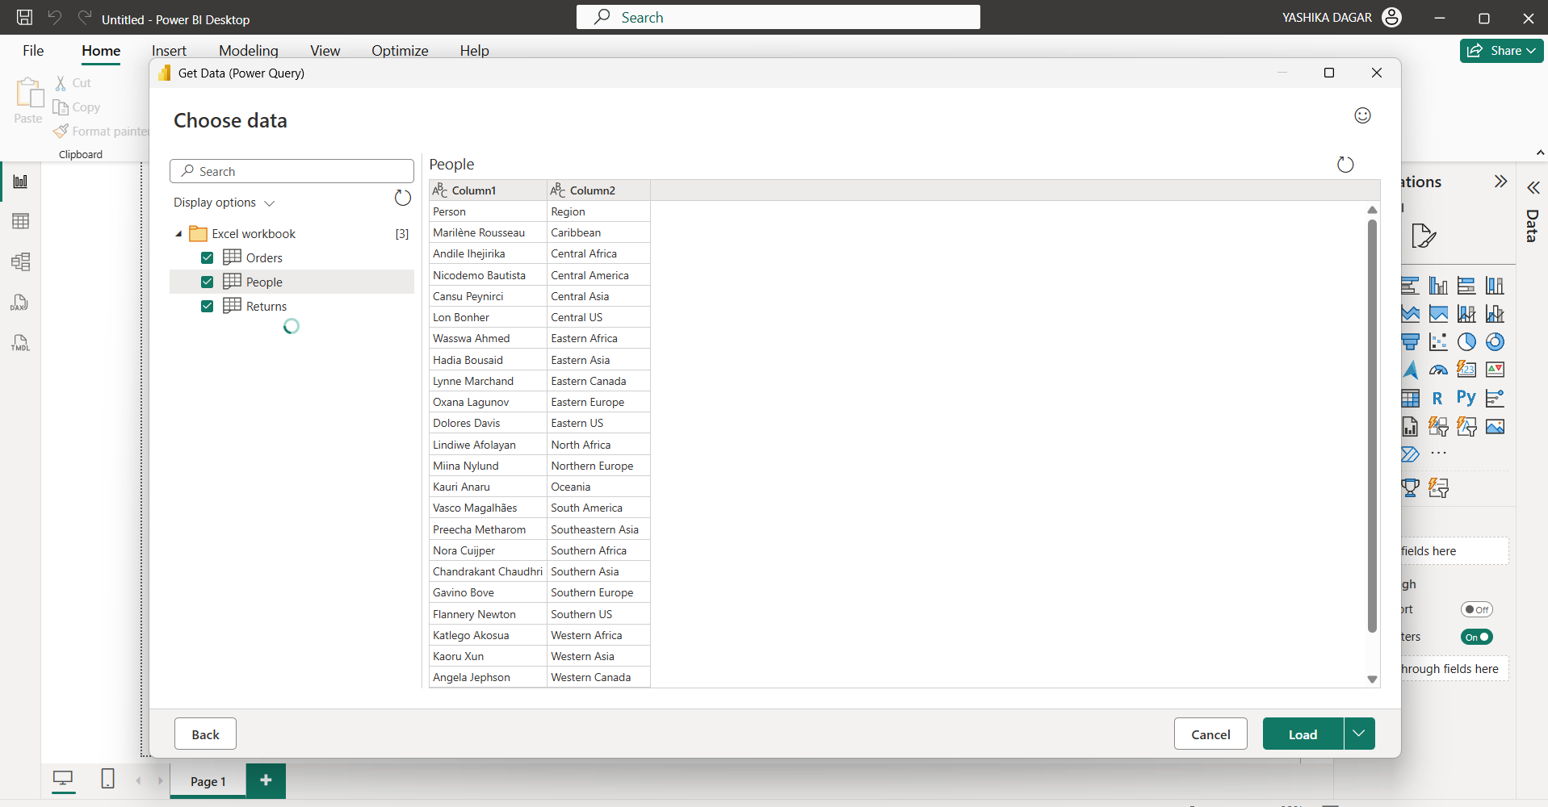

Step 4: Load and Verify
Click Load and verify that the imported tables are available in Power BI.
PART B – IDENTIFY FACT AND DIMENSION TABLES
Step 5: Analyze Orders
Analyze the Orders table and identify Sales, Profit, Quantity, and Discount.
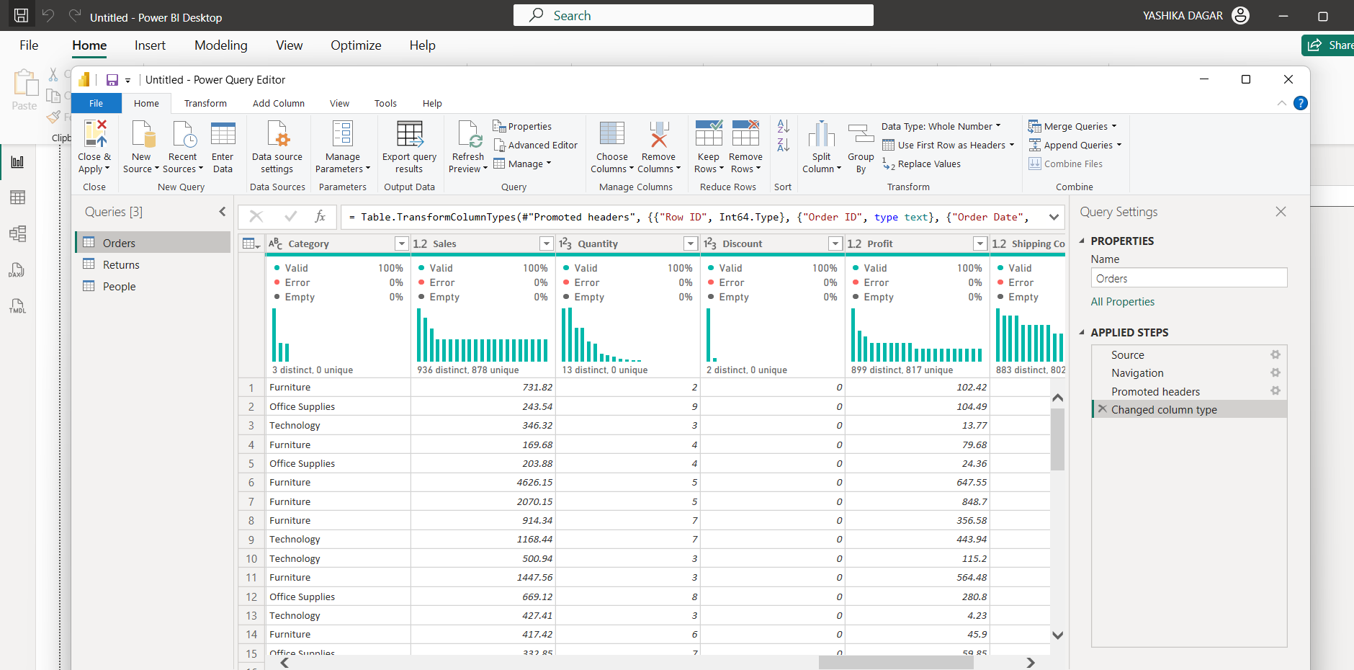
Step 6: Identify Descriptive Attributes
Identify Customer, Product, Region, and Date information.
Step 7: Categorize Attributes
Categorize attributes into Fact and Dimension tables.
PART C – CREATE DIMENSION TABLES
Step 8: Dim_Customer
Create Dim_Customer using Customer ID, Customer Name, and Segment.
Step 9: Dim_Product
Create Dim_Product using Product ID, Product Name, Category, and Sub-Category.
Step 10: Dim_Region
Create Dim_Region using Region, Country, State, and City.
Step 11: Dim_Date
Create Dim_Date using Order Date, Year, Quarter, and Month.
Step 12: Remove Duplicates
Remove duplicate records from all dimension tables.
PART D – CREATE FACT TABLE
Step 13: Create Fact_Sales
Create Fact_Sales containing Order ID, Customer ID, Product ID, Region, Order Date, Sales, Quantity, Profit, and Discount.
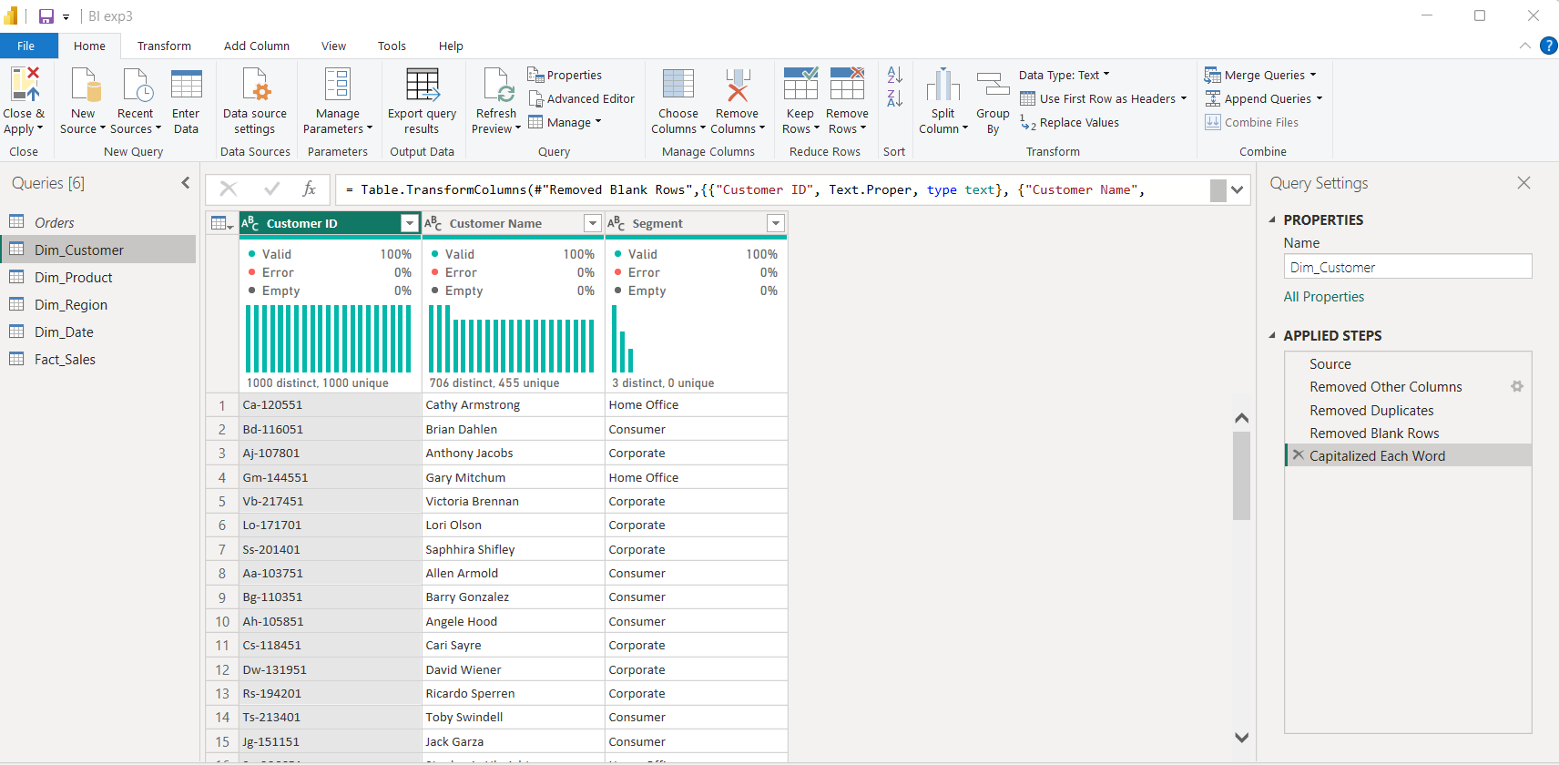
Step 14: Verify Keys
Verify all key columns required for relationships.
PART E – BUILD STAR SCHEMA
Step 15: Open Model View
Open Model View.
Step 16: Create Relationships
Create relationships between Fact_Sales and all Dimension Tables.

Step 17: Configure Relationships
Configure relationships as Many-to-One.
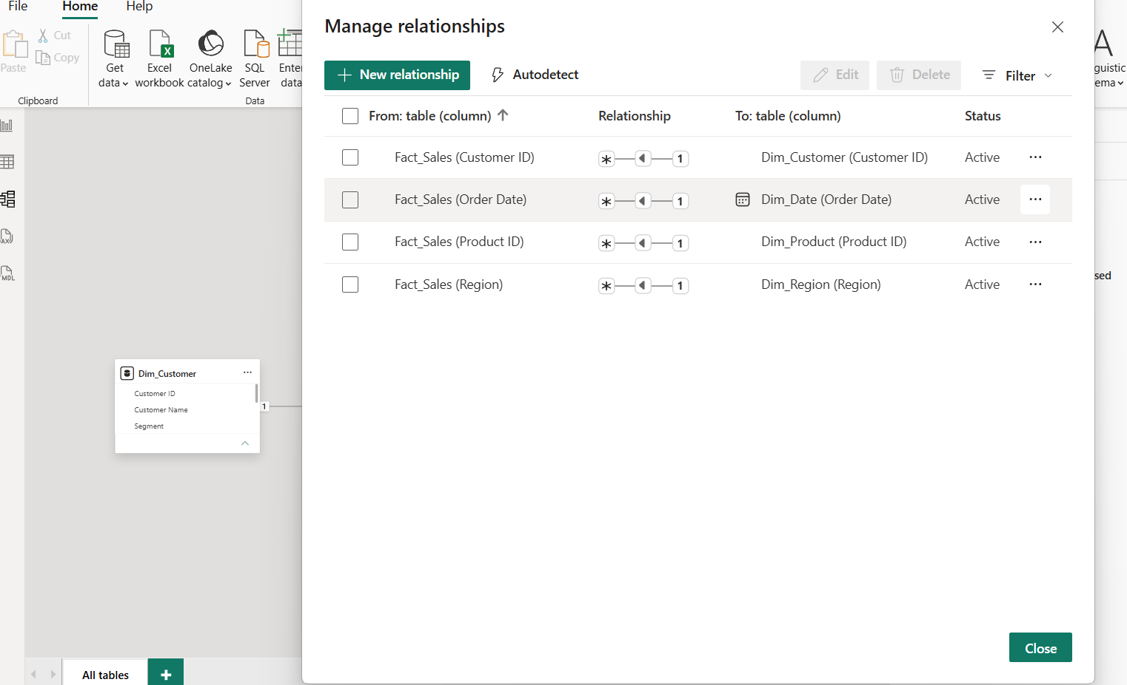
Step 18: Arrange the Model
Arrange the tables visually into a Star Schema layout.
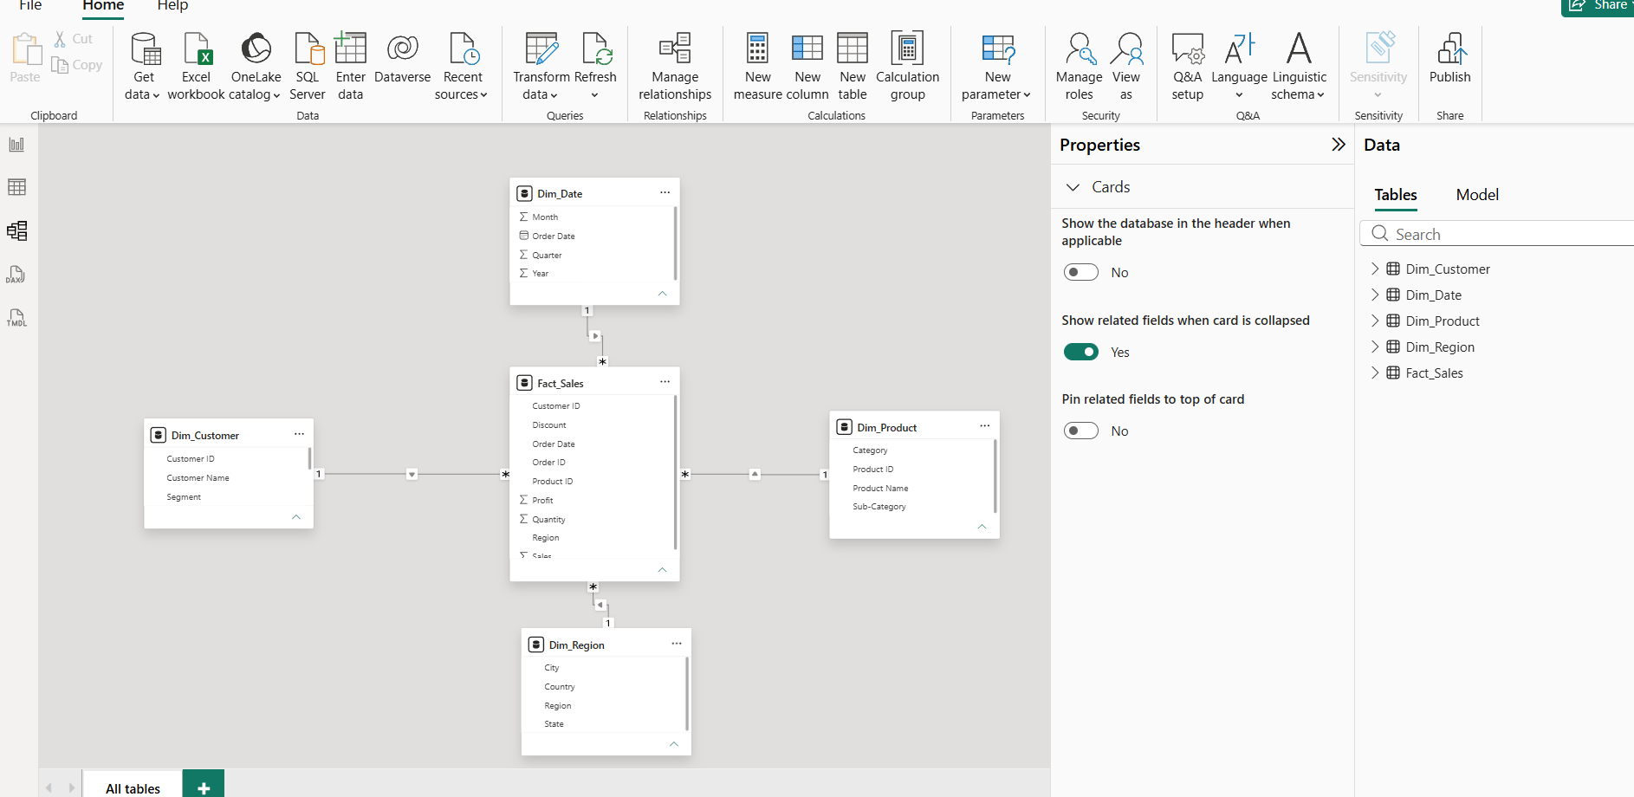

PART F – VALIDATE MODEL
Step 19: Create Visualizations
Create Sales by Category, Profit by Region, and Sales Trend by Year.
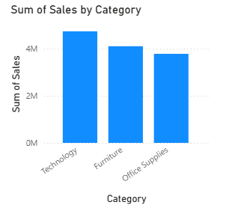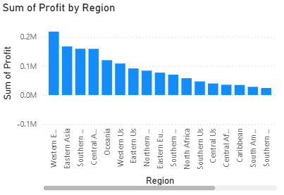
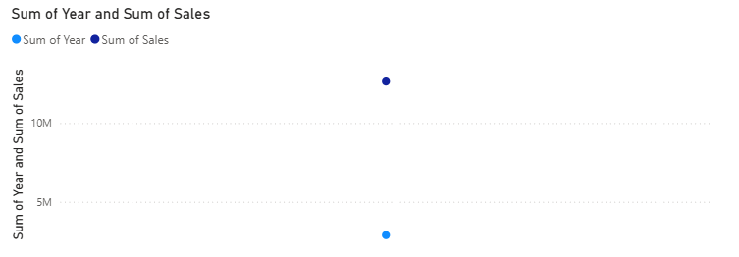

Step 20: Create DAX Measures
Create Total Sales, Total Profit, Profit Margin, and Average Order Value measures.
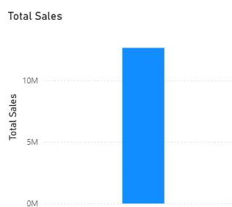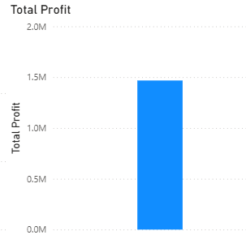
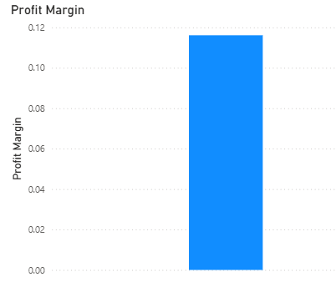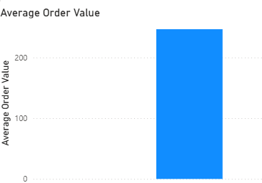

Step 21: Verify Filtering
Verify that dimensions correctly filter fact data.

